Incidental Influence: Walker Evans
Transforming Lives at Yale

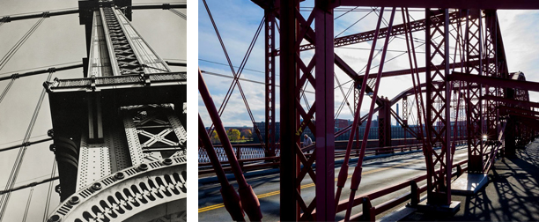

A conversation with Julian Fisher
Robert Hendrickson, Chris Pullman
Esther Pullman, Raymond Smith, and Tom Strong
moderated by Laura Wexler

Monday, May 7 · 4:30 pm

Room 108, Whitney Humanities Center

Sponsored by Public Humanities at Yale and the Whitney Humanities Center in conjunction with
the Gallery exhibit "Trapped in the Middle: Photographs by Julian Fisher"

