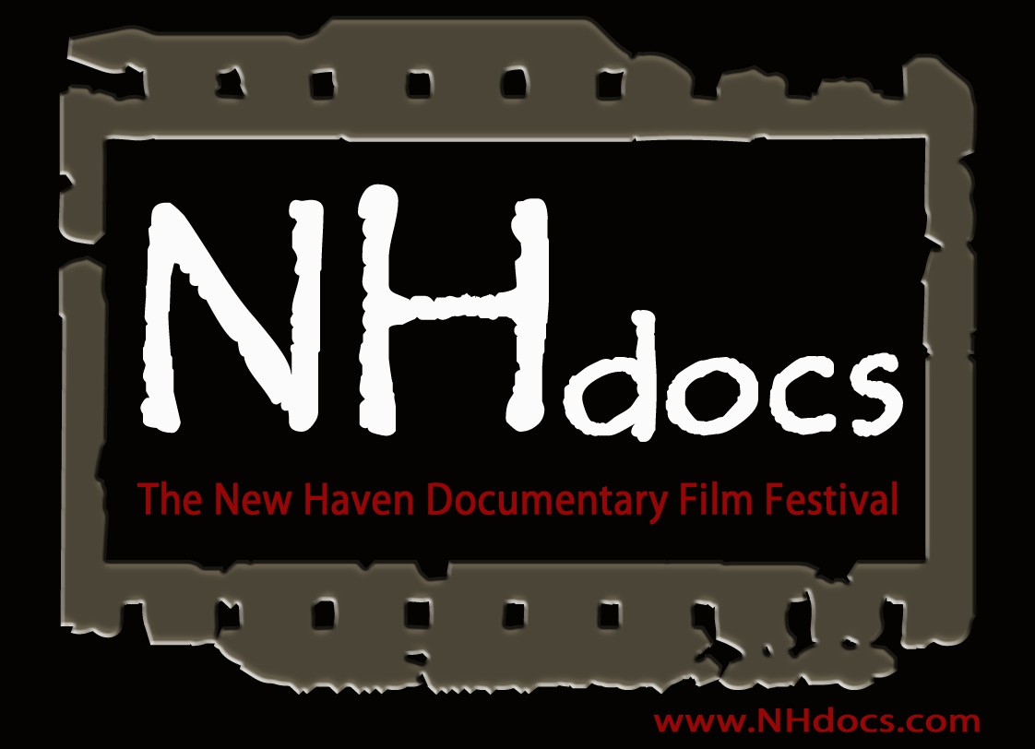
THE 2016 NEW HAVEN DOCUMENTARY FILM FESTIVAL ANNOUNCES ITS JUNE LINEUP.
ELEVEN DAYS OF FILMS, MOST BY AREA FILMMAKERS PLUS GUEST OSCAR-WINNER ALEX GIBNEY.

NEW HAVEN, CONNECTICUT, May 18, 2016: NHdocs: The New Haven Documentary Film Festival has expanded and combined forces with the International Festival of Arts and Ideas to present an impressive array of 15 documentary features and 26 shorts over an eleven-day period, from June 2 to 12. Screenings take place at Yale’s Whitney Humanities Center Auditorium, 53 Wall Street and, on Saturday afternoon, June 4th, at the New Haven Free Public Library, 133 Elm Street. They are free and open to the public:
NHdocs will feature a number of Connecticut premieres, including our opening night feature, Lloyd Kramer’s Midsummer in Newtown (2016), in which a theater production comes to Newtown, Connecticut, aimed at healing the hearts and minds of a community devastated by the school shooting. A set of Newtown-related shorts will have their world premieres on June 8th: Kim Snyder’s #We Are All Newtown and Notes from Dumblane and Sue Roman’s Team 26.
The festival features three music documentaries: Miss Sharon Jones!, directed by Oscar-winner Barbara Kopple, which follows the R & B queen while she battles with cancer and struggles to keep her band together. It is accompanied by a documentary about local musical icon Billy Fischer, who will perform following the films. From festival co-director Gorman Bechard, Who is Lydia Loveless?, a look at a rising star, and the difficulties of surviving in today’s music world. Ms. Loveless will perform a solo live show after the screening, which takes place at Café Nine.
The world of performance becomes the topic on Friday, June 3rd, beginning with an autobiographical documentary of Connecticut-raised and Rhode Island-based comedian Ray Harrington, Be a Man (2015). NHdocs explores into the seedy world of horror and other cult films that went straight to VHS Tom Seymour and Ken Powell’s VHS Massacre (2016) and concludes with the World Premiere of David Pilot’s Skin of the Game: The Raven Riley Story (2016), which follows the roller coaster trajectory of an internet porn star. (The festival has rated the film NC-17.)
Shorts subjects will be screened on Saturday afternoon (at the New Haven Free Public Library) and Sunday afternoon (at the Whitney Humanities Center), June 4th and 5th. After a recently-released documentary on the Panthers left New Haven out of the picture, NHdocs offers two films with a New Haven perspective on the Panthers: a recently restored version of Mayday (May 1st Media, 1970) and Elihu Rubin and Elena Oxman’s "Next Question": The May Day 1970 Oral History Project (2002). Elihu Rubin and former Black Panther George Edwards will lead a Q & A. NHdocs will then screen a dozen student documentaries from seven universities and one high school on Sunday. With Yale receiving repeated attention from the national media, the afternoon begins with three documentaries about different aspects of student life at Yale, notably the first public screening of Alex Defroand’s We Out Here: A Film About Race at Yale (2016). The afternoon will be concluded at 5:30 with a Student Award Ceremony in which the winners will be given cash prizes and other goodies.
As a benefit for the New Haven Animal Shelter, we present Darcy Dennett’s The Champions (2015), a documentary featuring the pit bulls rescued from NFL star quarterback Michael Vick’s notorious dogfighting ring. The screening will be followed by a discussion on animal law with representative Diana Urban and Prosecutor Joseph LaMotta. Two documentaries made by NHdoc veterans screen on Monday night: Rebecca Abbott’s Ireland's Great Hunger and the Irish Diaspora (2015), which explores the historical and socio-political circumstances leading to potato failure, mass starvation and death in Ireland, and Karyl Evans’s Letter from Italy, 1944: A New American Oratorio. (2015), which focuses on the creation of a musical drama by two sisters, Sarah Meneely-Kyder and Nancy Meneely, about their father, a WWII Yale-trained medic who returned home to his family with post-traumatic stress disorder. Both filmmakers will be present to discuss their films and the challenges of addressing trauma in their work.
On Thursday, June 9^{th,} NHdocs unveils the prize-winning film festival hit documentary The Angel of Nanking (2015), in which a man patrols a bridge over the Yangtze River in China, trying to prevent jumpers from ending their lives. It is followed by the world premiere of Amanda Chemeche’s Radical Hospitality (2016), which looks at the Karen refugees sponsored by the Mennonites of Lancaster, PA, and by Kelly Colbert’s His Name is Midnight (2015), the story of a prince to pauper rodeo horse with an unstoppable will to survive. The filmmakers will be at all the screenings.
NHdocs is offering several innovations for its third annual festival. On Saturday, June 4, at 11 am, it will offer a panel on Guerilla Filmmaking. Veteran filmmakers will offer tips on fund raising, fair use practices, film festival applications, distribution strategies and more. On Thursday afternoon, June 9th, New Haven area filmmakers will screen excerpts of their work in progress. Both events take place in Room 208, Whitney Humanities Center.
Finally, on June 10-12, NHdocs joins forces with the International Festival of Arts and Ideas to present a three-day retrospective: Revealing Scams, Lies, Trickery and Deceit: The Documentaries of Alex Gibney. Friday evening pairs Gibney’s breakthrough hit, Enron: The Smartest Guys in the Room (2005), with his Oscar-winning Taxi to the Darkside (2007), which explores the American military's use of torture by focusing on the unsolved murder of an Afghani taxi driver. On Saturday afternoon, Gibney will conduct Q & A’s following the screenings of Client 9: The Rise and Fall Eliot Spitzer (2010), which explores the hidden contours of hubris, sex and power that led to New York Governor Spitzer’s downfall, and The Armstrong Lie (2013), which looks at the fall from grace of sports legend Lance Armstrong. Sunday afternoon will feature Emmy award-winning Going Clear: Scientology and the Prison of Belief (2015), an investigation of The Church of Scientology. The Gibney retrospective concludes with a panel on the Documentary Art of Investigation and Revelation with Gibney, journalist Jake Halpern, and novelist Chandra Prasad.

The Third New Haven Documentary Film Festival was made possible by a host of sponsors and supporters including:
The Office of New Haven and State Affairs, Yale University
Department of Arts, Culture and Tourism, City of New Haven
The Whitney Humanities Center
Films at the Whitney, supported by the Barbakow Fund for Innovative Film Programs at Yale
The Program in Public Humanities at Yale
What We Were Thinking Films
Willoughby’s Coffee
Yale Film and Media Studies Program
Yale Film Study Center, courtesy of Paul L. Joskow
Yale Institute of Sacred Music
Yale Summer Session
Yale Summer Film Institute
For more information please visit: www.NHdocs.com
or email directors Gorman Bechard at: NewHavenDocs@gmail.com and Charles Musser at: charles.musser@yale.edu

About NHdocs
Our Origins: NHdocs came together in 2014 when four filmmakers from New Haven gathered together for the first time . . . in Missoula, Montana. That’s right: The Big Sky Documentary Festival in Missoula. And despite being from the same town, a few of us had never met before. It made us realize how desperately New Haven needed a film festival that could bring filmmakers together and help build community.
Our Philosophy: NHdocs seeks to build a sense of community among documentary filmmakers from the greater New Haven area (and we are quite inclusive in our reach!). Many of these filmmakers work as independents, some teach at universities in the area, while others rely on various kinds of day jobs. We look forward to showing work that has been or will be shown at prominent International Film Festivals, but we also want to show work being done in the city’s schools and by students at nearby universities. We are resolutely democratic in our embrace of the documentary tradition on the local as well as the international level. We can learn from and support each other.
Our Audience: NHdocs wants to help filmmakers find audiences for their documentaries. And we are presenting documentaries for audiences with a wide range of interests. This year this will include historical documentaries; music docs; portraits of artists; documentaries about social issues such as immigration, race relations and animal rights; and others that grapple contemporary realities such as the war in Afghanistan and the dissembling of government officials, sports icons and business titans. Our line up is filled with remarkable surprises. Come and find out what your neighbors have been doing.
The Organizers: NHdocs co-directors Gorman Bechard and Charlie Musser are veteran filmmakers who span the infamous town-gown divide. New Haven-born Bechard has been making documentaries (and some fiction films) since 1983. Charlle Musser has been teaching documentary filmmaking and a range of courses on film history/theory and criticism at Yale since 1992. Our two other co-founders (Lisa Molomot and Jacob Bricca) taught at Wesleyan but have moved to Arizona. The directors have now teamed up with local filmmakers Karyl Evans, head of the Student Competition Jury, and Rebecca Abbott. Essential support also comes from Festival Manager Katherine Germano and Operations Coordinator Anthony Sudol.

